CERR assessed the effectiveness of auctions on the public procurement portal
The Center for Economic Research and Reforms (CERR) developed the Auction Bidding Performance Index (Index), which assesses the effectiveness of the results of the organization and implementation of procurement processes by government customers. It is important to note that such an Index is being formed for the first time in Uzbekistan.
June 21, 2021 Tashkent. CERR conducted an analysis of public procurement on the Public Procurement Information Portal (xarid.uz) for the period from January 2020 to April 2021.
The aim of the study was to determine the effectiveness of procurement procedures for goods purchased by government agencies and state-owned enterprises through auctions to reduce the starting price.
The study included the following areas:
Analysis of the competition between suppliers at the level of a specific product;
Evaluation of the public procurement process at the level of the auction lot by compiling a consolidated Index, including more than 7 indicators;
Evaluation of the effectiveness of government customers by creating their Rating on the basis of the auction lots organized by them.

METHODOLOGY
Auction performance index was assessed for each lot using seven criteria, such as contract value, category weights, price reduction from the starting price, number of bidders, bidding status and anomalies in data or procurement suspicion.
Anomalies were found for two indicators, such as the price reduction from the starting price and the starting amount of the contract. Complex algorithms were used to identify anomalies or outliers.
To analyze the effectiveness of the public procurement process, source data of the Uzbek Commodity and Raw Materials Exchange (UzEX) was used. During the analysis, the data were processed and cleaned, after these indicators were formulated based on a literature review.

APPLICATION
The obtained results can be applied in the following areas:
- To optimize the efficiency of the public procurement process mechanism in the form of an auction;
- An increase in the number of suppliers of goods where the competition between suppliers during the auction is too low;
- Advanced training of officials among state-owned companies in planning public procurement;
- Simplification of the public procurement process by adding additional features to a special public procurement portal.
- Saving public resources through more efficient organization of the public procurement process.
RESULTS
During the period from January 2020 to April 2021, on the public procurement portal, 5,330 budgetary and 1,347 corporate organizations held 131,759 auctions, the number of contracts amounted to 3.9 trillion soums.
There is an inverse relationship between the number of applications and the contracts: the more applications, the lower the price, which leads to savings in public resources.
In the auctions of budgetary organizations, an average of 5 suppliers participated in each lot (in corporate auctions - 4) and submitted 13 bids (in corporate auctions - 10).
The largest price reduction is noted for:
"Stationery" - 38%,
“Clothes, shoes and bedding” - 38%,
"Sports inventory and equipment" - 34%,
"Sound recording technique and equipment" - 32%,
"Musical instruments" - 32%.

Slight price reduction:
"Biologically active additives" - by 5%,
"Prosthetic and orthopedic raw materials for dentistry" - 7%,
"Software product" - 9%.
They were attended by an average of 2 suppliers.

AUCTION PERFORMANCE INDEX
During the research, CERR developed the Auction Bidding Performance Index, which assesses the effectiveness of the results of the organization and implementation of procurement processes by government customers.
The criteria for evaluating the Index were economy (the amount of the auction and the percentage price reduction from the starting price), competitiveness (number of participants), planning and suspiciousness of purchases (percentage reduction in prices that went beyond the lower or upper quantile, at times), conflict (not execution of the contract after its signing).
The index has combined all of the above indicators into a single indicator. The Index values range from -7 to 7: worst (-7 to -3.5), poor (-3.5-0), low (0-2.3), average (2.3-4, 6) and high efficiency (4.6-7).
During the period under review, the average value of the Index was 2.09 (budget - 2.28, corporate - 1.86), which corresponds to a low efficiency group. Since January to April of this year the index decreased from 2.09 to 1.77, which is mainly due to a decrease in the share of successfully completed contracts from 79% (average in 2020) to 73%. In the example of budget customers, this figure dropped from 84% to 73%.
The index was calculated for each lot, taking into account each type of product.
The study found that musical instruments (0.92), recording equipment and equipment (1.07), clothing, shoes and bedding (1.13), sports equipment and equipment (1.23) were purchased with the least efficiency.
Rating of state customers
The authors of the study summarized the index values and compiled an efficiency rating that published more than 10 auctions (1596 budget and 617 corporate customers, 236 Republican-level customers).
The Center for Economic Research and Reforms offers to get acquainted with the full list of participants of the 2020 rating - government customers on the website Review.uz
Rating of government customers in Uzbekistan for 2020 — Review.uz
- Rating of budget customers;
- Rating of corporate customers;
- Rating of customers of republican significance.
Among budget customers, at the bottom of the rating were:
Cardiological dispensary of Bukhara region (1596th place, 67% of contracts were terminated), Children's and Youth Sports School of Yukorichirchik District (1595th place), Department of Medical and Social Service of Syrdarya Region (1594th place, relatively high starting prices for 18% of auctions), the Public Fund for Support of Non-Governmental Organizations and Other Civil Society Institutions under the Council of People's Deputies of the Samarkand Region (1593rd place, a relatively high price decline in 47% of auctions), Department of Preschool Education of the Uzbekistan Region (1592nd place) and the Department of Preschool Education of the Namangan region (1591st place).

Among corporate customers, the lowest rating is held by Termez branch of AKB Agrobank (617th place), Toshrangmetzavodtools LLC (616th place, a relatively high price decline in 44% of auctions), Issiklik Manbai OJSC in Bukhara region (615th place, relatively high starting prices for 89% of auctions), the Directorate for the Management of Small Industrial Zones of Tashkent (614th place) and "Navai branch of AKB Khalkbank" (613th place).
The analysis showed that in 18% of cases the contracts were canceled.
Ranking among the customers of republican significance, the Agency for Youth Affairs (1387th place), the Ministry of Innovative Development (1496th place), the Agency for the Development of Nuclear Energy under the Ministry of Energy of the Republic of Uzbekistan (1541st place), the State Testing Center (1543th place), National Library of Uzbekistan named after A. Navoi (1560th place).
In particular, of the 67 contracts signed by the National Library, 28 (42%) were terminated. A higher starting price was announced in 29 auctions compared to other deals. Similarly, 37% of the contracts of the State Testing Center were terminated. At the same time, a relatively high decline in prices was observed for 30% of auctions.

61% of republican-level organizations entered the rating with low efficiency. For organizations at the regional and district / city levels, this number is 52% and 45%, respectively.
In terms of sectors, auctions with comparatively higher efficiency of customers were carried out in the field of support for the makhalla and the family (2.56 - average efficiency), secondary specialized education (2.50), health care (2.41), landscaping (2.40) and irrigation and agriculture (2.28).
The lowest efficiency was observed in the sectors of archives (1.62), employment and labor (1.73), energy (1.85), economics and finance (1.9).
It should be noted that at the first stage of the study, the effectiveness of the results and implementing procurement processes is assessed only on the basis of auction data. In the future, CERR plans to develop a comprehensive index that will contain an analysis of the effectiveness of customers in tenders, competitions and direct purchases.

Khasanjon Majidov, Leading Researcher, CERR
Bakhtiyor Ismailov, Leading Researcher, CERR

Fig. 1. The total amount of signed contracts by category
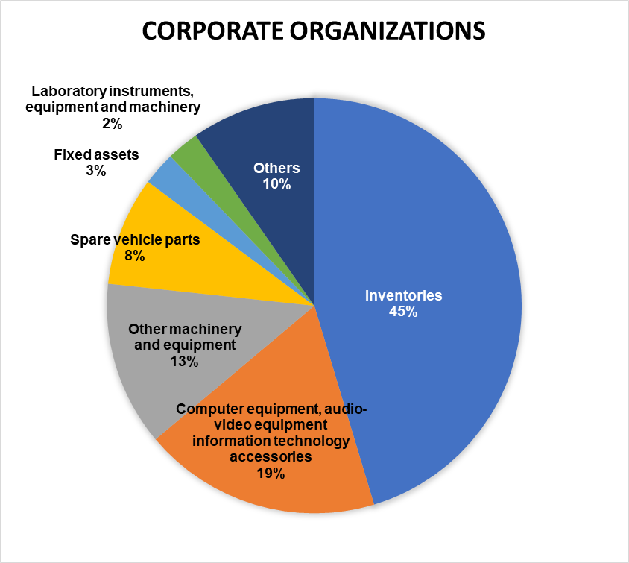

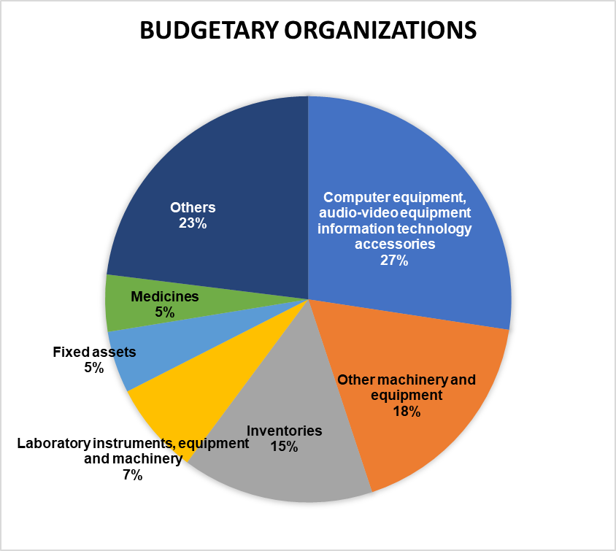

Fig. 2. Dynamics of the efficiency index and the number of lots.

