Ukraine Food Companies – Israel Trade Mission

To: Food Importers, Food Processors, Supermarket and Retail Chains

An official delegation of 11 Ukrainian food manufacturers is coming to Israel and are interested in finding importers, agents and clients for their products and services.

The delegation will be available, at no cost, for prearranged B2B meetings:

- Monday, 26 November between 14:00 - 18:00 in the Tel Aviv area

- Tuesday, 27 November between 10:00-17:00 at Israfood Exhibition at Tel Aviv Convention Center (Ganei Hataarucha)

Please review the 11 company descriptions below and let us know what meetings we can schedule for you.

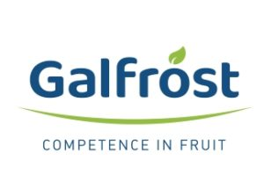
Galfrost (http://galfrost.com.ua/en) produces high-quality fruit ingredients for food companies and retail chains. Galfrost grows and processes Individually Quick Frozen (IQF) and freeze-dried conventional/organic fruits including strawberries, raspberries wild blackberries, wild bilberries (EU blueberry), wild cranberries, etc. for fruit processors and retail companies who belong to such well-known international groups like DANONE/Agrana, NESTLE, Mondeleze and KRAFT FOODS for use in finished products such as yogurt, juices, covered chocolates, breakfast cereals/muesli, etc. The company has a HACCP plan as well as FSSC 22000, organic (EU organic, KRAV, NOP) and kosher (OK) certification.

Bud’mo Zdorovi (http://smakuli.com) specializes in manufacturing gluten-free and lactose-free cookies under the SMAKULI trademark. The company offers 6 types of cookies, all with no artiﬁcial ﬂavors, colors or preservatives: vanilla, walnut, coconut, chocolate chunk, candied fruits and chocolate. Its products are currently sold through Ukraine's biggest retailers, as well as health/specialty food stores, coffee houses and food distributors. The company uses zip-lock packages to preserve freshness of the products. The company has ISO 22000 (HACCP, ISO 9001) and Halal certification.

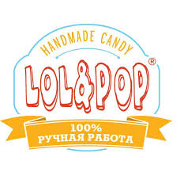
LOL&POP (http://en.lolandpop.ua/), established in 2013, makes 100% handmade candy from natural ingredients, without any preservatives, artiﬁcial colorings and ﬂavors. LOL&POP has two retail stores in Ukraine. As well, the products are sold in various retail outlets, including Ukraine’s largest eco- and health product chain, stores selling products for children and premium wine and food chains all over Ukraine.

Its products include marshmallows, jellies, lollipops and hard candy. Besides retail sales, the company promotes and sells its products also via customized individual orders, corporate orders and workshops. The company has HACCP certification and is capable of receiving kosher certification for specific product batches. The company's product was sold in Israel until 2017 and is now seeking a new importer or agent.

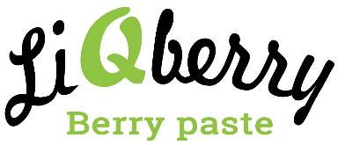
Liqberry (http://www.liqberry.biz/) manufactures organic pastes, a finished product, made from the wide assortment of fresh berries: cranberry, blueberry, cowberry, aronia (chokeberry), raspberry, blackberry, and common sea buckthorn. The products are made using unique technology which allows extraction of all the useful elements that are usually lost during consumption of fresh berries, including essential Omega oils from the seed. Some 20 scientific studies have confirmed strong positive impact of the products for normalization of blood sugar level, especially concerning diseases like diabetes and coronary artery disease. Liqberry pastes are sold in retail stores, health and organic stores, and pharmacies. They are exported to Germany, Poland, the UAE, Japan and Estonia. The company has ISO 22000 and organic certification.

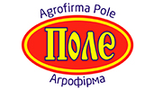
Agrofirma “Pole” (http://agropole.com.ua) grows and markets a range of both organic and conventional agricultural raw materials, including its flagship product organic hulled millet, as well as lentils, chickpeas, durum wheat, peas, thistle, barley, rye, flax, oats, etc. Agrofirma cooperates with 15 Ukrainian agricultural enterprises with total organic area of 9,000 hectares. The company exports over 5,000 tons annually to such locations as the Netherlands, Germany, Austria, Great Britain, Italy, Belgium, Australia, Malaysia, Poland, Czechia and France. The company has Equivalent European Union Organic Production & Processing Standard and FSSC 22000 certification.

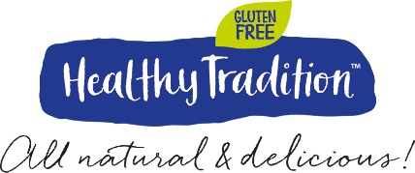
Healthy Tradition (https://healthy-tradition.com) produces natural gluten-free dried snacks without sugar, preservatives, chemicals, emulsifiers and flavor enhancers. Its line includes cookies, nutrition bars, granola, roll ups and crisp bread. The products are carefully slow-dried at a low temperature for up to 24 hours in order to preserve vitamins and minerals. Each product has a simple list of ingredients and a unique taste, differentiating the company from peers. The company sells via primarily online stores like Amazon and a German gluten-free international online provider, while its products are very appropriate for hotels, airlines, duty-free shopping, schools and other venues.

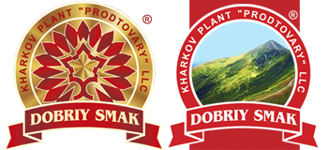
Prodtovary (https://hzpt.com.ua/en/) makes confectionary products, including biscuits, cookies, wafers, wafer and souffle sweets at affordable prices. Besides retail and supermarket chains in Ukraine, the products have also been sold in the Baltics, Romania, Belarus and Iraq. The company is very flexible to adapt the products themselves and the packaging to the needs of any market or clients. The company has ISO 22000 and Halal certification.

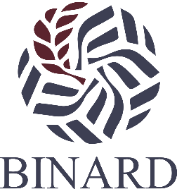
Binard (http://www.sorghum.com.ua) specializes in the production of 100% natural gluten-free SORGHUM GROATS and FLOUR, which is necessary for a wide audience of dietary, healthy and special food consumers all over the world. The company grows and processes only high-quality sorghum, which is grown in Ukraine under the company’s complete control. The company also produces SPELT GROATS and FLAKES. All natural products are non-GMO and do not contain preservatives. The products are popular in Ukraine and sold in the largest retail national food chains and health/specialty food stores. Binard also sells its products to wholesalers and grain processors who pack them for their markets or use them to produce finished products. Private label service from Ukraine is possible as well. The company is in the process of obtaining ISO 22000 certification and is able and willing to attain kosher certification for the Israeli market.

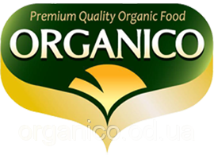
TM ORGANICO (http://organico.ua/) manufactures a variety of quality organic oils which are cold pressed (Extra virgin) and not refined. The range of products includes: sunflower, high-oleic sunflower, flaxseed, camelina, rapeseed, pumpkin and hemp oil. The products are sold in major retail chains, supermarkets and health/organic specialty stores in Ukraine as well as exported to European countries. The company has organic certification and can supply the oils in bulk, bottled and private label.

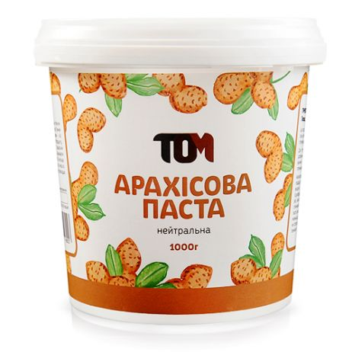
TOM (https://www.maslotom.com/en/home) is a young (founded in 2012) company and a leading peanut butter maker in Ukrain. The company produces various natural nut butters, honeys, teas, granola, flaxseed crisps and other items. No stabilizers, preservatives or other harmful additives are added. The major products are peanut butter and nut butters. Their peanut butter line includes classic/sweet/salty peanut butter, chocolate peanut butter, peanut butter & chocolate chips, crunchy/honey peanut butter, peanut butter & dried cranberries, peanut butter & crunchy chocolate, peanut butter & chocolate chips, crunchy peanut butter with white chocolate & dates, and peanut butter with dates & coconut oil. The nut butters include a variety of combinations and flavors of almonds, cashews and hazelnuts. Since the company controls the entire cycle of production, product recipes can be easily adjusted according to customers' wishes. The products are currently sold online and in the company’s own retail shops, as well as a network of supermarkets, health stores, distributors and confectioneries throughout Ukraine. They are also distributed in Germany, Slovakia and Poland. The products are generally packaged in glass and plastic jars of various volumes (180g, 300g, 500g, and 1000g). The company has ISO 22000 and HACCP certification (The company is undergoing the process of obtaining ISO22000 and HACCP certification).

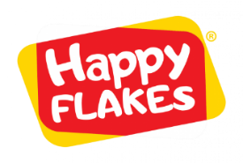
Sovarog (http://myhappyflakes.com/ http://sovarog.com/) specializes in processing, packaging and exporting cereals to different markets. Based on its long-time expertise in producing agro-commodities, the company sources the best grains to produce natural and healthy cereals including wheat, rye and barley flakes, as well as white oats and quick oats. These products are positioned for mass market and known to be cheaper than competing products.

