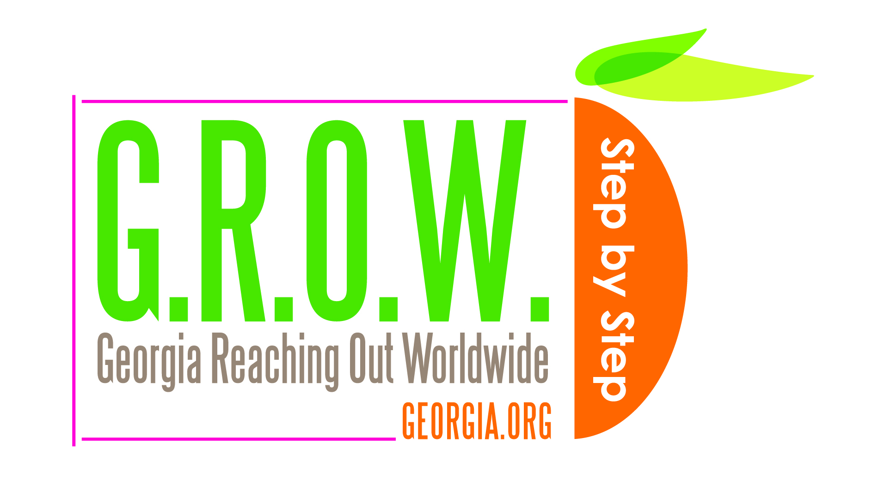
G.R.O.W. Program
Georgia Reaching Out Worldwide
Incoming Buyer/Rep Information

The Georgia Department of Economic Development is accepting applications for its 2014 G.R.O.W. (Georgia Reaching Out Worldwide) Program which provides international buyers/representatives the opportunity to meet with small- and medium- sized Georgia companies. The G.R.O.W. event is scheduled for the week of May 12-16, 2014, with two business days in Atlanta, two business days in Savannah and a day to travel between these cities. The event will focus on five industries, as indicated below.

International buyers, distributors and manufacturers’ representatives in the targeted industries are encouraged to apply. A limited number of participants will be selected based on qualifications listed in the application and on a first-come, first-served basis. Interested applicants are encouraged to apply early. Participants selected for this program will receive an honorarium of $4,000, post-event.

About Georgia
Georgia is home to numerous small businesses offering a variety of innovative products and services with potential for sales in international markets. Georgia is the 12th largest exporting state and home to approximately 10,000 exporters.

Georgia sits at the crossroads of global trade. Home to 3000 international facilities, over 130 consulates, honorary consulates, trade commissions and bi-national chambers from 70+ countries, Georgia is located in the heart of one of the fastest-growing regions in the USA. Georgia is home to numerous Fortune 500 companies including but not limited to The Coca-Cola Company, United Parcel Service (UPS), Delta Air Lines, The Home Depot, Newell-Rubbermaid, NCR, and many more. The Georgia Department of Economic Development staff is well-trained, professional, and will help make this initiative a success for the international business delegation as well as our Georgia companies.

Targeted Industries for the 2014 program

Agricultural Equipment and Technologies

Agriculture/Food

Defense and Security Products and Technologies

ICT (Information & Communication Technologies)

Medical Equipment and Technologies

International Buyers/Representatives: Benefits of Participation
- Mutually beneficial business opportunities
- Opportunity for up to 20 pre-screened one-on-one appointments with Georgia companies
- Paid honorarium of $4,000 (post-event per terms of Participation Agreement)
- Opportunity to experience Georgia

Expectations of all International Participants
- Complete “International Buyer/Representation Evaluation” forms pursuant to terms of Participation Agreement.

This opportunity is offered through funding received from a grant by the Small Business Administration. For additional information: please contact the State of Georgia’s international representative who has provided this information to you.

