Company Profile

COMPANY NAME: Arkopa Ahşap Panel San. A.S.

WEBSITE:
www.arkopa.com.tr
YEAR OF ESTABLISHMENT: 2002 |  | NO OF EMLOYEES: 189

1. ARE YOU INTERESTED IN: EXPORTING IMPORTING BOTH

2. descriBE the activity/PRODUCTS/SERVICES YOU SEEK TO PROMOTE
Wooden panel, wooden profiles, Laminated Kitchen Tops, Door Profiles

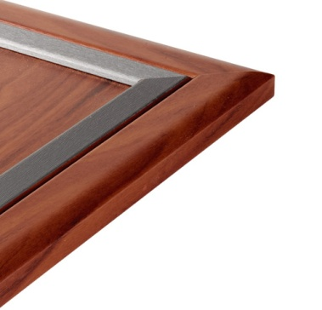
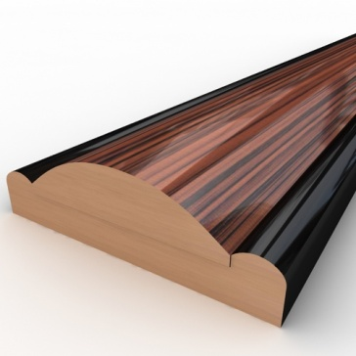
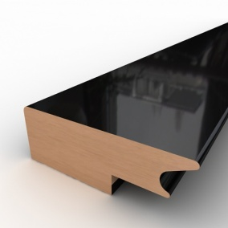

End consumer of your products:
- Households,
- Furniture Manufacturers,
- Interior Designers
- Building & Construction companies

Main applications of the product:
- Children’s room
- Bedroom
- Living Room & Dining Room
- Kitchen & Bathroom

3. COMMERCIAL PROFILE

Main factor of competitiveness of your company:

Design Price / quality
Quality Brand name / Presentation
Technology Range of product
Other (specify):

4. MARKET INFORMATION

What type of business contacts you are seeking:

Importer/Distributor/Wholesaler
Agent/Sales Representative
Franchising
Joint Venture Partner
License
Other (specify):

Is your company in contact with local companies? Yes No

Do you want to contact some specific companies? Yes No

If yes, specify the name and the address of the companies:

5. ADDITIONAL COMMENTS/INFORMATION ABOUT YOUR BUSINESS:

ARKOPA has been founded in Kayseri Organized Industrial Zone, Turkey and works as a side industry supplier of furniture components comply with "ISO 9001 - 2008 & TSE" quality standars.

ARKOPA produces human and environment friendly furniture components with its latest technology machinery site operated by specialised team taking into consideration right price levels for the right qualities.

ARKOPA creates different solutions throughout continues research and development for standard and customized furniture design where mdf, particle board, plywood, solid wood are moulded and wrapped, overlayed with decorative materials like pvc, laminate, natural veneer and finish foil.

