Company Profile

COMPANY NAME: Hiss Kamış Sanayi Ticaret ve İhr. Ltd. Şti.

WEBSITE:
www.gardenandbeach.com

YEAR OF ESTABLISHMENT: 1984

1. ARE YOU INTERESTED IN: EXPORTING IMPORTING BOTH

2. descriBE the activity/PRODUCTS/SERVICES YOU SEEK TO PROMOTE
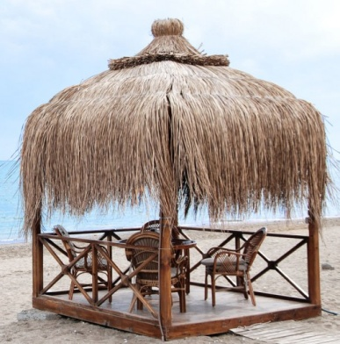
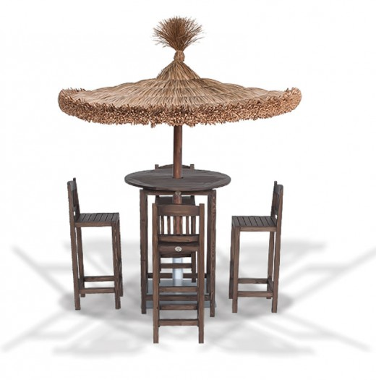
Reed panel, garden furniture, straw umbrella

End consumer of your products:
- Turnkey construction companies (Hotels and residential units),
- Hotel Procurement Departments,
- Municipalities,
- Households.

Main applications of the product:
Furniture for all kind of open-air areas such as;
- Gardens & parks
- Hotels,
- Restaurants,
- Beaches

3. COMMERCIAL PROFILE

Main factor of competitiveness of your company:

Design Price / quality
Quality Brand name / Presentation
Technology Range of product
Other (specify):

4. MARKET INFORMATION

What type of business contacts you are seeking:

Importer/Distributor/Wholesaler
Agent/Sales Representative
Franchising
Joint Venture Partner
License
Other (specify):

Is your company in contact with local companies? Yes No

Do you want to contact some specific companies? Yes No

If yes, specify the name and the address of the companies:

5. ADDITIONAL COMMENTS/INFORMATION ABOUT YOUR BUSINESS:

Hiss Reed Ltd. was established in 1984 as the first company in the sector in Turkey and proudly developed as the sector leader.

In the begining our company was producing and marketing only straw roof from reed. Since 2004, our company has started production of ecological building materials made from reed.

Reed is nice to look at and very robust/resistent, perfectly applicable for the garden.

Reed is an ideal building material for the garden because of its stability and elasticity to resist the wind and its aesthetical appearance.

