Company Profile

COMPANY NAME: Taya Endustriyel Urunler Dıs Ticaret Ltd. Sti.

WEBSITE:
www.taya.com.tr

YEAR OF ESTABLISHMENT: 2005

1. ARE YOU INTERESTED IN: EXPORTING IMPORTING BOTH

2. descriBE the activity/PRODUCTS/SERVICES YOU SEEK TO PROMOTE
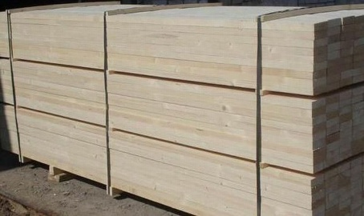
Timber, Plywood, Oriented Strand Board
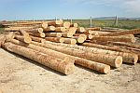
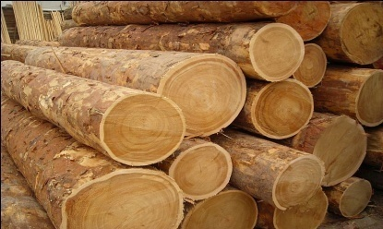
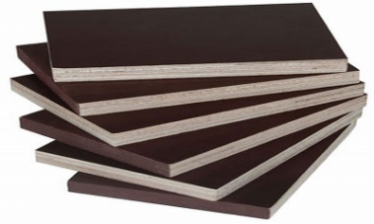

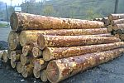

End consumer of your products:
- Building & Construction companies,
- Boat & ship constructors,
- Furniture Manufacturers,
- Flooring materials producers,
- Other wooden article producers

Main applications of the product:
All kind of wood products such as;
- Furniture
- Floor and wall coverings
- Doors & Windows
- Other wooden Building & Construction products, etc.

3. COMMERCIAL PROFILE

Main factor of competitiveness of your company:

Design Price / quality
Quality Brand name / Presentation
Technology Range of product
Other (specify):

4. MARKET INFORMATION

What type of business contacts you are seeking:

Importer/Distributor/Wholesaler
Agent/Sales Representative
Franchising
Joint Venture Partner
License
Other (specify):

Is your company in contact with local companies? Yes No

Do you want to contact some specific companies? Yes No

If yes, specify the name and the address of the companies:

5. ADDITIONAL COMMENTS/INFORMATION ABOUT YOUR BUSINESS:

In 2005, our company established in Istanbul. Our company serves with success in the foreign trade sector with the business concept based on quality and timely delivery.

