Get to Know Croatia –
A Reliable Business Partner

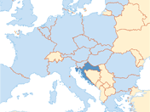

INTRODUCTION:

General Information:
Area: 56,594 km²
Population: 4.3 million
Capital: Zagreb (800,000 inhabitants)
Currency: Croatian Kuna (HRK)
1 EUR = 7.63 HRK, 1 USD = 6.9 HRK
GDP (2014): 43.1 bn EUR
GDP per capita (2014): 10,158 EUR
Inflation (2014): - 0.2 %
Unemployment rate (ILO, 2014): 17.3 %
Average net salary (Jan 2015): 737 EUR
Export (2014): 10.41 bn EUR
Import (2014): 17.23 bn EUR
FDI: 29.4 bn EUR (1993-2014)

Main trading partners (2014): Italy (14.11 %), Germany (13.63 %), Slovenia (11.02 %), Austria (7.70 %), Bosnia-Herzwgowina (6.14 %), Hungary (5.43 %), Russia (4.13 %), Serbia (3.15), …, China (1.78 %), Israel (0.14 % ).
Export Products: Mineral Fuels; Machinery, Mechanic Appliances; Electric Machinery; Wood & wooden articles; Pharmaceutical Products
Leading Foreign Investors: Austria, the Netherlands, Germany, Hungary, Luxembourg, Italy, France, Slovenia, Switzerland.
Foreign Companies already active in Croatia

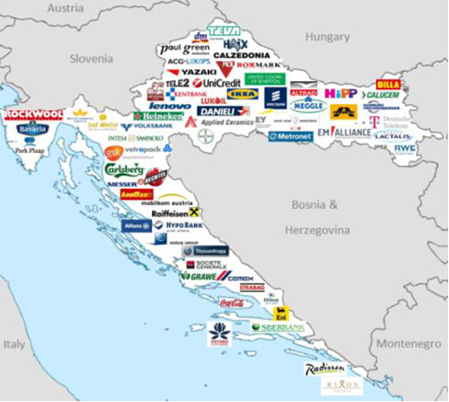

Export Potentials of Croatia – by active sectors:

Information-Communication Technology
Pharmaceutical Industry
Electric Equipment
Wood & Wood Processing Industry
Food and Food-Processing Industry
Metal Industry
Automobile Industry
Textile Industry
Construction Industry
Ship-building
Chemical Industry
Why is Croatia a reliable business partner?

Because…

- Croatia has a good geo-strategic position which offers a quick access to a market of over 500 million people.
- Croatia offers stability & safety of business activity.
- Croatia offers a stimulating investment climate – pro-business oriented environment which encourages new investments and ensures stability
- Croatia has highly educated, multilingual & competent workforce.
- Croatia has a modern transport infrastructure.
- Croatia is EU member (1 July 2013)→ which access to a market of over 500 million people - Possibility of using EU funds

Croatia also offers…

STIMULATING INVESTMENT ENVIRONMENT

- Equal rights for foreign and domestic investors
- Free transfer of return on equity from the country
- Avoidance of double taxation
- 0% profit tax on reinvested capital
- Numerous incentives for business activities to investors

INVESTMENT PROMOTION ACT

- Tax incentives (reduction of profit tax to 10-0%; regular profit tax 20%)
- Employment grants (up to 18,000 EUR)
- Education grants (up to 80% of costs).
- Initial and capital expenses.
- Labor intensive investment projects

Incentives for:

- manufacturing activities, technology centers, strategic business support and high value-added services, tourist activities (4 plus star hotels..)

REQUIREMENT:

Minimum investment: 150,000 EUR + 5 new workplaces
Micro entrepreneurs: 50,000 EUR + 3 new workplaces

INVESTMENT POTENTIALS

INDUSTRY
- 17.8% of GDP (2014)
- 18.5% of total employment (2014)
- Investment possibilities: Pharmaceutical, ICT, wood, textile & leather processing, metal, automobile, electric, chemical, plastic & rubber industry.

ENERGY

- Project of building LNG Terminal on the island of Krk, Croatia
- Project of building the pipeline infrastructure in the Croatian part of the Ionian-
Adriatic Pipeline
- Adriatic Gas Corridor: Croatia-Hungary-Ukraine
- Research and exploatation of hydrocarbon in Croatia

AGRICULTURE AND FOOD PRODUCTION

- 6.5% of GDP; 4.8% of total employment (2014)
- 1.3 million hectares of utilized agricultural area
- Wide range of products (wine, cereals, fish, olives, fruits, vegetables etc.); internationally known food products – confectionary, diary products, olive oil, Mediterranean fruits
- Investment potential in aquaculture and health food production.
- There are already companies with kosher certificate.

TOURISM

- Natural beauty combined with culture heritage
- Revenue: 7.4 bn EUR (17.2% of GDP; +2.8%)
- 13.1 mil tourists (+5.6%), increase in tourist traffic in all counties
- 66.5 mil overnight stays (+2.6%)
- Priority – Investments in high quality tourist facilities
- Investment possibilities: Nautical tourism, Health & wellness tourism, Congress tourism

INVESTMENT LOCATIONS

- More than 100 ready entrepreneurial zones – utility services, clear ownership, good logistics & traffic connection
- Strong support form local communities
- Additional tax reliefs:
- relief from utility tax
- lower payments for municipal services
- lower land prices

Invest in CROATIA ... how to proceed: useful contacts

- Economic Diplomacy – MFA Croatia
http://gd.mvep.hr/en/

- Embassy of Croatia Tel Aviv
http://il.mvep.hr/

- Ministry of Economy of Croatia
www.mingo.hr

- Croatian Chamber of Commerce
www.hgk.hr
www.investincroatia.hr

- Agency for Investments and Competitiveness
www.aik-invest.hr

- Export website of the Government of the Republic of Croatia
www.izvoz.gov.hr

- http://croatia.eu/

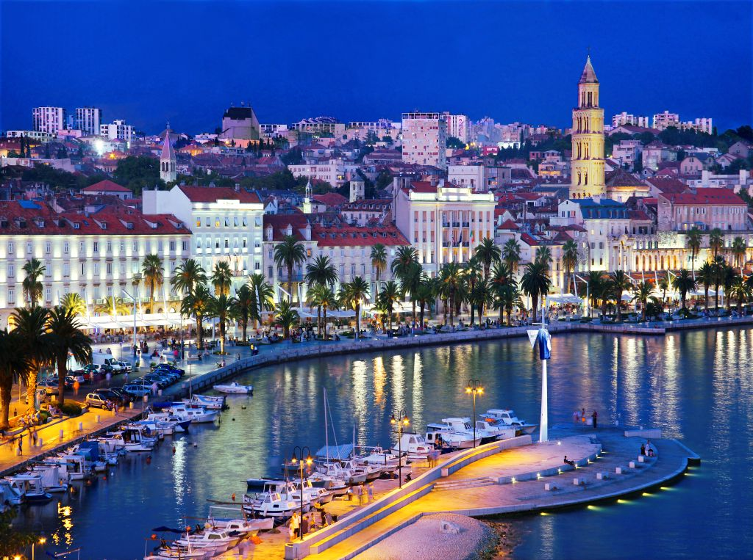
Croatian Tourism Board, photo: Ante Verzotti (Split)

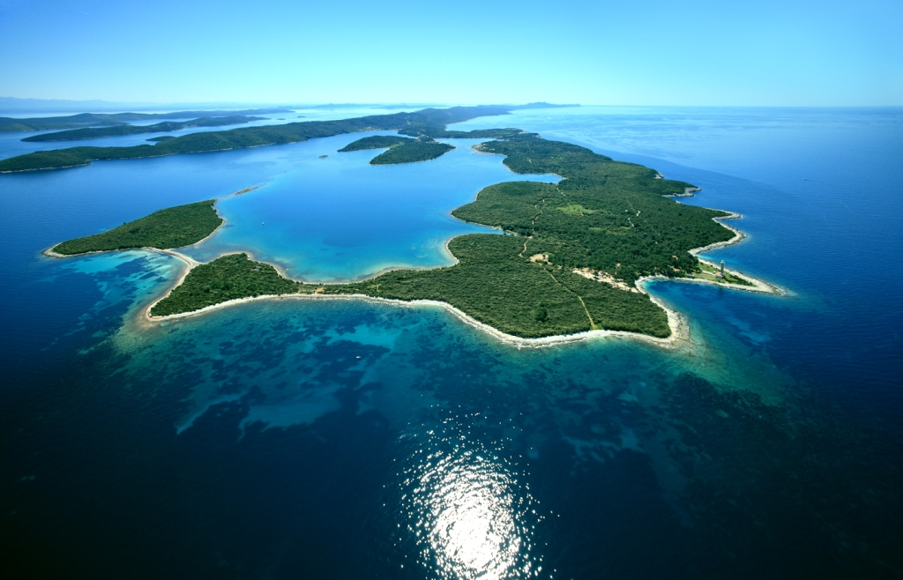
Croatian Tourism Board, photo: Boris Kacan (Dugi otok island)

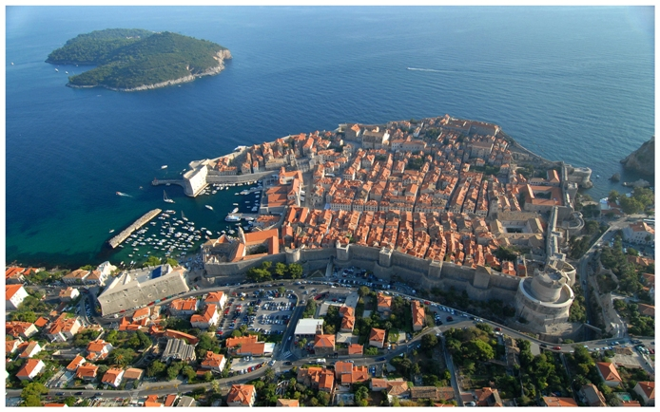
Croatian Tourism Board, photo: Ivo Tomljenović (Dubrovnik)

