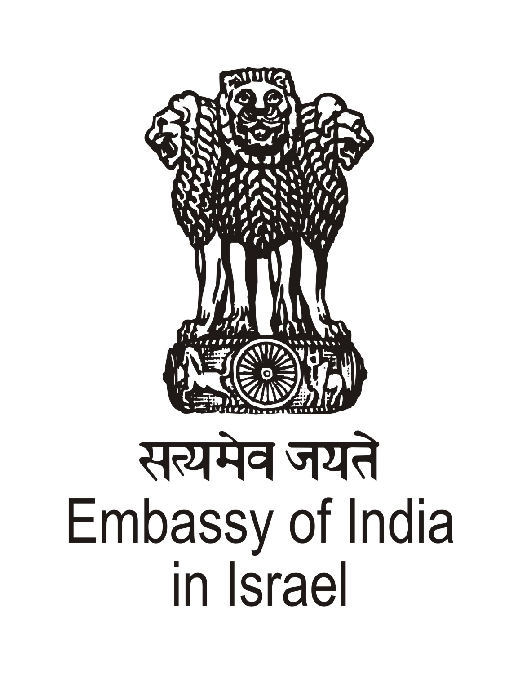
Seminar on

“India’s Electronics, Systems Design and Manufacturing Industry:
Opportunities for Collaboration and Investment”

Building 10, Hall A4
Ganei Hataarucha (Exhibition Grounds), Rokach Boulevard, Tel Aviv
Sunday, 16 June 2013

Moderator: Ms. Vani Rao, Deputy Chief of Mission, Embassy of India
0815- 0900: Registration, Networking and Breakfast
0900 hrs: Welcome address by Ambassador Mr. Jaideep Sarkar
0905-0920 hrs: Remarks by Mr. J. Satyanarayana, Secretary, Department of Electronics & Information Technology
0920-0935 hrs: Keynote address by Mr. Kapil Sibal, Minister for Communication and Information Technology
0935–1000 hrs: “Government of India’s Policy on Promotion of Electronics System Design and Manufacturing Sector & Roadmap for development of Electronic Industry in India” Presentation by Dr. Ajay Kumar, Joint Secretary(International Cooperation & Industrial Promotion), Dept of IT and Electronics.
1000-1030 hrs: Presentations by India’s corporate leaders on “Successful models, opportunities and challenges of doing business with India”
1030-1050 hrs: Question & Answer Session
1100 – 1300 hrs: B2B meetings in seminar venue

- Seats are limited. Please confirm at the earliest.
- For registration please confirm to Commercial Wing
Email: eoitlvcom@indembassy.co.il ; Tel: 03-5220631

