How the demand for real estate has changed in Uzbekistan
The Center for Economic Research and Reforms analyzed changes in the real estate market in Uzbekistan in June 2021.
July 23, 2021 Tashkent. The Center for Economic Research and Reforms (CERR) regularly analyzes changes of demand in the real estate and car markets. Changes of demand in these markets indicate a recovery of economic activity in Uzbekistan.
In June this year, the number of concluded real estate contracts amounted to 21.5 thousand, which is 16.8% more than in May. Compared to June 2019 (14.3 thousand), the number of concluded contracts for real estate increased by 50.6%. However, compared to June 2020, a decline was recorded by 36% (33.6 thousand), this is due to the fact that that last year a breakthrough was recorded in the real estate market, due to the gradual easing of strict quarantine measures after the imposed lockdown. At the same time, in June 2020, the number of real estate contracts in the country increased by 135.2% compared to June 2019 (14.3 thousand), while in Tashkent this figure (4.5 thousand in June 2019) increased by 148.7%.
Fig. 1. Index of changes in the number of executed contracts for the purchase and sale of real estate in June 2021.
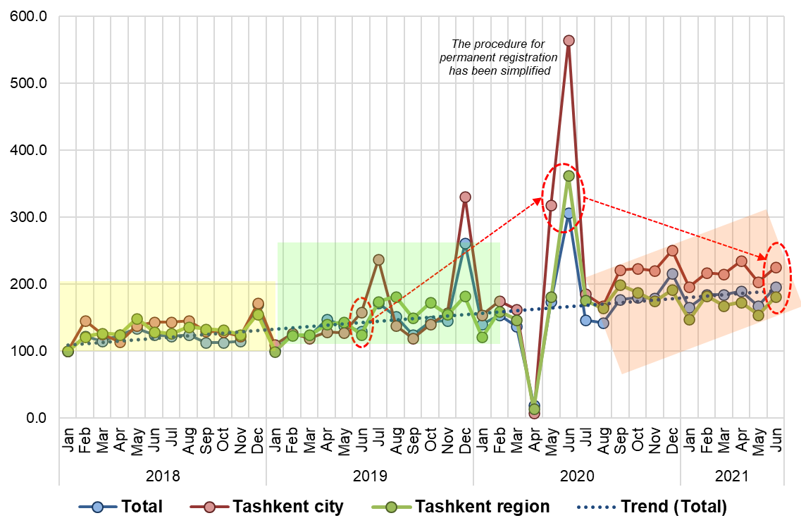

In the context of regions, growth in comparison with May was observed in all regions of the republic. The highest growth rates were observed in Samarkand (31.7%), Fergana (27.1%), Namangan (26.2%), Jizzakh (25.7%) and Navoi (22.6%) regions.
Fig. 2. The relationship between mortgages and real estate sales
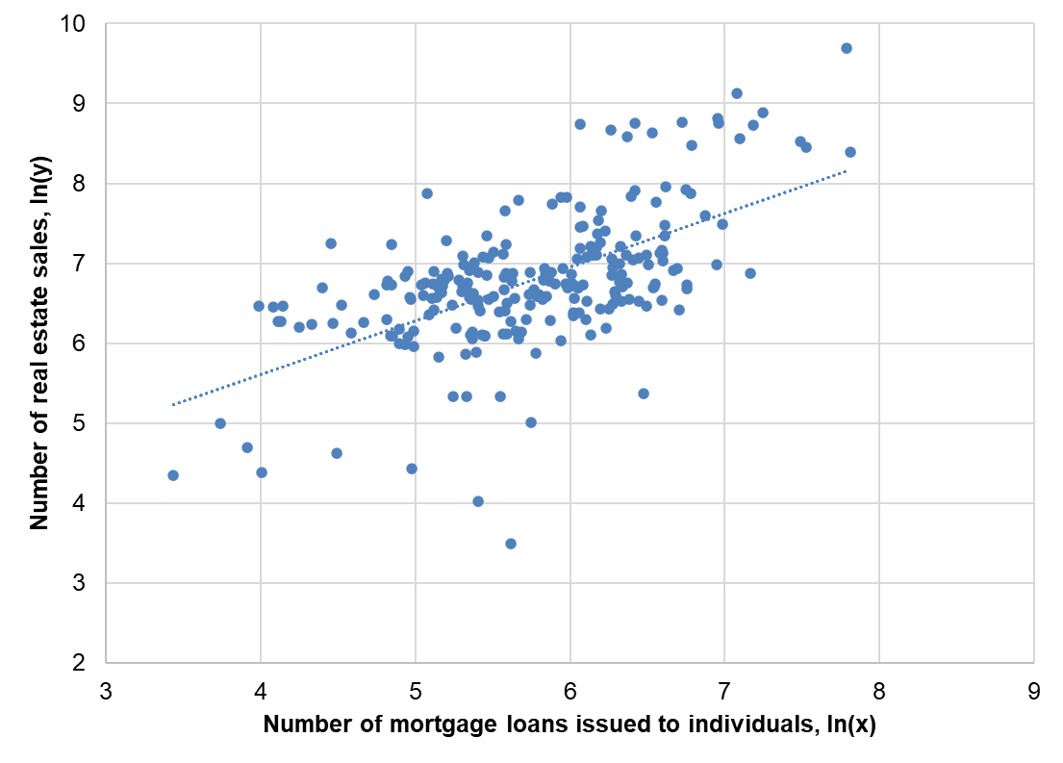
The analysis shows that there is a significant correlation between mortgage lending and real estate sales. An increase in the number of mortgage loans by 10% leads to an increase in real estate sales by an average of 6.7%.
The volume of mortgage loans provided to the population in January-May 2021 amounted to 2.77 trillion.soums, while the number of these loans reached 21.1 thousand.
In the context of regions, the largest number of mortgage loans fell on the city of Tashkent (4012, and the volume - 809.4 billion soums), Fergana (2122, and the volume - 248.1 billion soums), Surkhandarya (1782, and the volume - 185, 1 billion soums), Tashkent (1524, and the volume - 185.1 billion soums) and Andijan (1508, and the volume - 226.7 billion soums) regions.

Fig.3. Mortgage loans provided to the population in January-May 2021
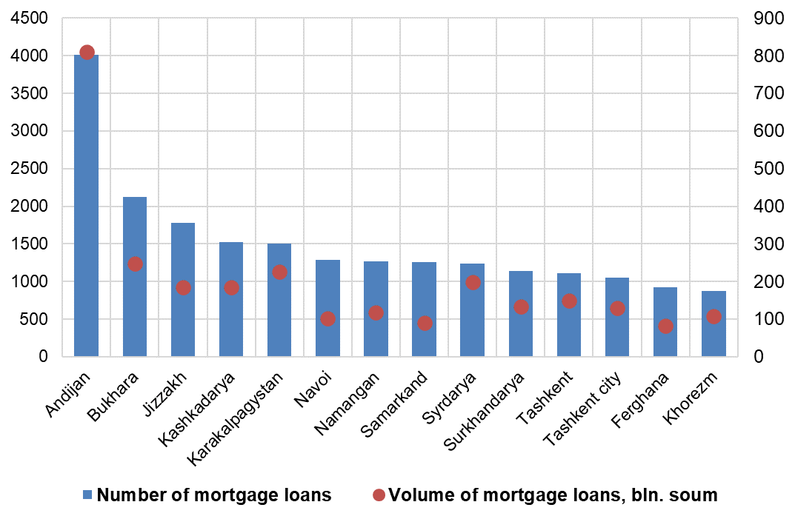

Khalilullokh Khamidov, Chief Researcher, CERR

