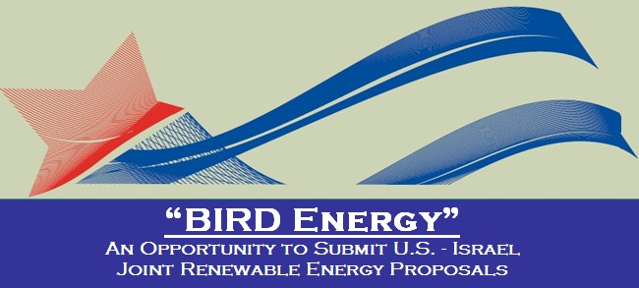

The U.S. Department of Energy (DOE), the Israel Ministry of Energy and Water Resources
and the BIRD Foundation have established “BIRD Energy”: a program for
U.S. - Israel joint renewable energy developments

“BIRD Energy” follows the same rules and procedures as BIRD.
Please refer to BIRD’s website for submission details - www.birdf.com.
To be considered, a project proposal should include:

• R&D cooperation between two companies or cooperation between a company and a university/research institution (one from the U.S. and one from Israel).
• Innovation in areas such as: Solar Power, Alternative Fuels, Advanced Vehicle Technologies, Smart Grid, Wind Energy or any other Renewable Energy/Energy Efficiency technology.
• Significant commercial potential; the project outcome should lead to commercialization.

The maximum conditional grant is $1M per project.
Timetable and deadlines:
Executive Summary - Wednesday, June 26, 2013
Final Proposal - Wednesday, August 21, 2013
Decisions - November 2013

For further inquiries please contact:
In Israel: Ms. Limor Nakar-Vincent, limorn@birdf.com, Tel: 972-3-698-8315
In the U.S.: Ms. Andrea Yonah, andreay@birdf.com, Tel: 609-356-0305

