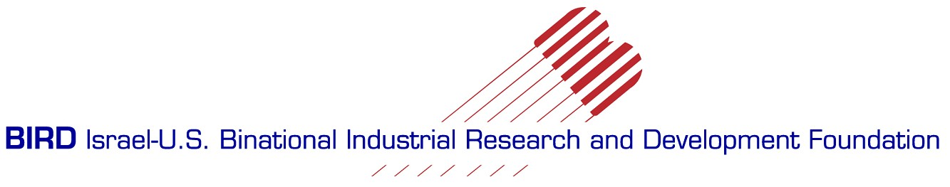

BIRD – Israel – U.S. Binational Industrial R&D Foundation to invest
$11 million in 14 new projects

The approved projects involve innovations in the areas of medical devices, water technologies, energy, neurotechnology, cyber security and more.

June 17, 2013 – During its meeting on June 5, 2013, the Board of Governors of the Israel-U.S. Binational Industrial Research and Development (BIRD) Foundation, approved $10.95 million in funding for fourteen new projects between Israeli and American companies. In addition to the grants from BIRD, the projects will access private sector funding, boosting the total value of all projects to approximately $33 million. The semi-annual meeting was held at the campus of the National Institute of Standards and Technologies (NIST), Gaithersburg, MD.
The BIRD Foundation promotes collaboration between Israeli and American companies in various technological fields for the purpose of joint product development. In addition to providing conditional grants of up to $1 million for approved projects, the Foundation assists by working with companies to identify potential strategic partners and facilitate introductions.
The fourteen projects approved by the Board of Governors are in addition to the 863 projects which the BIRD Foundation has approved for funding during its 36 year history. To date, BIRD’s total investment in these projects has been over $300 million, helping to generate direct and indirect sales of more than $10 billion.
The approved projects are as follows:
- Accells Technologies Ltd. (Israel) and 41st Parameter, Inc. (Scottsdale, AZ) will develop a capability for mobile authentication with device detection to fight cyber-attacks.
- Asymmetric Medical Ltd (Israel) and Flextronics (Irving ,CA) will develop asymmetric laser tools for surgery.
- Curapipe (Israel) and Milliken (Spartanburg, SC ) will develop a leakage cure system for urban water pipes.
- Dor Chemicals Ltd. (Israel) and Turbulent Energy LLC (Buffalo, NY) will develop and commercialize diesel/methanol hybrid fuels.
- Freshpoint Quality Assurance Ltd (Israel) and West Pharmaceutical Services (Exton, PA) will develop novel printable integrated threshold indicators for monitoring the quality of unit level pharmaceutical products.
- Hanita Coatings (Israel) and Whirlpool Corporation (Harbor, MI) will develop super-efficient thermal insulation for refrigerator doors through an integrated vacuum insulation technology.
- InSightec Ltd, (Israel) and Focused Ultrasound Surgery Foundation (Charlottesville, VA) will develop non-invasive brain surgery for movement disorders..
- iReveal Design Automation (Israel) and Forte Designs Systems (San Jose, CA) will develop an electronic system level verification product.
- Kadoor Microelectronics and Broadcom (Irvine, CA) will develop a RF MEMs switch.
- Nortec (Israel) and Gas Technology Institute (Des Plaines, IL) will develop and manufacture an advanced barcoding solution for underground asset lifecycle tracking.
- Novoxel (Israel) and Edge Systems Corporation (Signal Hill, CA) will develop an aesthetic/medical product line based on novel thermal technology
- Rambam Health Corporation (Israel) and Orlucent (San Francisco, CA) will develop a molecular imaging system for melanoma detection.
- TransBioDiesel (Israel) and Heliae Development (Gilbert, AZ) will develop high value esters for nutraceuticals using 3rd generation enzymatic technology.
- Water Flow Tech (Israel) and Mueller Water Products (Atlanta, GA) will develop a capability for low flow detection.

Dr. Eitan Yudilevich, Executive Director of the BIRD Foundation, said: “In this cycle, BIRD’s Board of Governors approved a relatively large number of joint, innovative projects between U.S. and Israeli companies, in diverse sectors, including several areas of high national priority for both countries, such as: cyber security, alternative fuels, energy efficiency and water technologies.”
Mr. Phillip Singerman, Associate Director for Innovation and Industry Services at the National Institute of Standards and Technology (NIST), and co-Chairman of BIRD Board of Governors said: “The funded projects reflect the continuing evolution of the BIRD program, especially by engaging small and medium size U.S. firms. Eight out of the fourteen U.S. grantee companies are SMEs, an indication of the growing importance of the connection to the global marketplace”.
Mr. Avi Hasson, Chief Scientist at the Ministry of Economy and co-Chairman of the Board said: “The BIRD Foundation is an excellent example of the potential which comes from international cooperation in research and development. Past projects’ successes and the high level of the projects we approved at the recent Board meeting indicate that such cooperation leads to opportunities for companies to break into global markets, increases jobs and stimulates economic growth.“
The deadline for submission of Executive Summaries for the next BIRD cycle is on September 10, 2013. Approval of projects will take place in December 2013.
About the BIRD Foundation
The BIRD (Binational Industrial Research and Development) Foundation works to encourage cooperation between Israeli and American companies in the various areas of technology, and provides free assistance in locating strategic partners from both countries for developing joint products.
The BIRD Foundation supports projects without receiving any rights in the participating companies or in the project itself. The financial assistance is repaid as royalties from sales. The Foundation provides support of up to 50% of a project’s budget, beginning with R&D and ending with the initial stages of sales and marketing. The Foundation shares the risk and does not demand that the investment be repaid if the project fails to reach the sales stage.
The BIRD Foundation works in full cooperation with the Chief Scientist’s Office at the Ministry of Economy in Israel, and with the U.S. Commerce Department’s National Institute of Standards and Technology (NIST).

