Company Profile

COMPANY NAME: Seyhan Inş. Hiz.Tur.Nak.San.Tic.Ltd.Sti.

WEBSITE:
www.seyhanpalet.com

YEAR OF ESTABLISHMENT: 1992 |  | NO OF EMLOYEES: 110

1. ARE YOU INTERESTED IN: EXPORTING IMPORTING BOTH

2. descriBE the activity/PRODUCTS/SERVICES YOU SEEK TO PROMOTE
Producing wooden palette, timber, wooden chest.
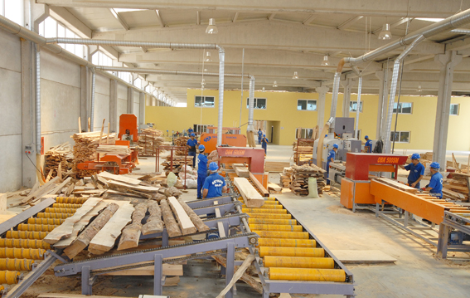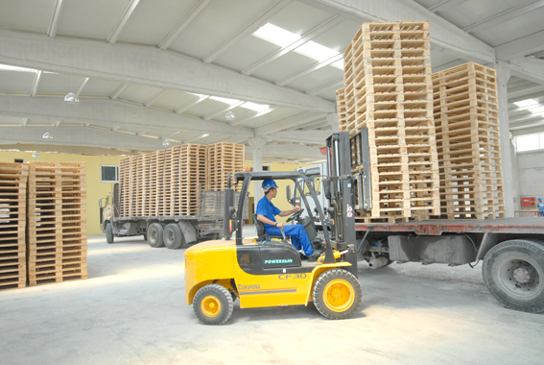

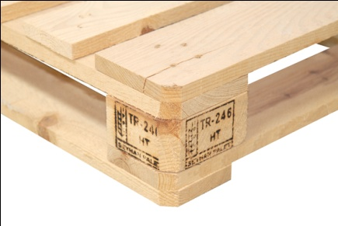
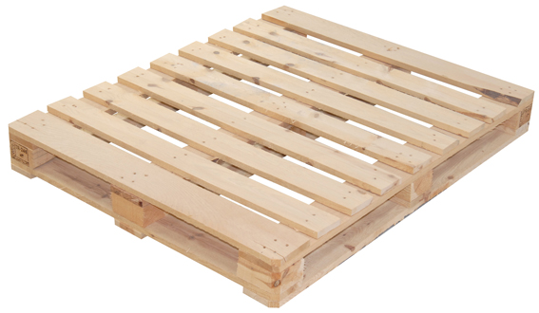
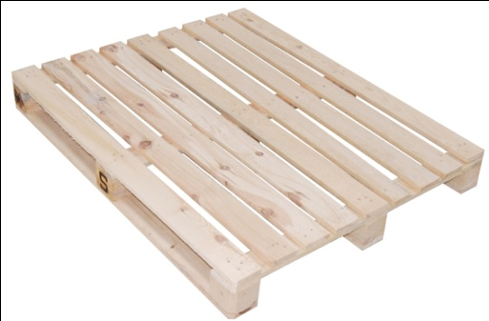

End consumer of your products:
- Freight forwarding, shipping companies,
- Large Scaled Manufacturers/Exporters (Especially food industry, other industries)

Main applications of the product:
- Transportation of goods

3. COMMERCIAL PROFILE

Main factor of competitiveness of your company:

Design Price / quality
Quality Brand name / Presentation
Technology Range of product
Other (specify):

4. MARKET INFORMATION

What type of business contacts you are seeking:

Importer/Distributor/Wholesaler
Agent/Sales Representative
Franchising
Joint Venture Partner
License
Other (specify):

Is your company in contact with local companies? Yes No

Do you want to contact some specific companies? Yes No

If yes, specify the name and the address of the companies:

5. ADDITIONAL COMMENTS/INFORMATION ABOUT YOUR BUSINESS:
Our company was founded in 1992. Their branches in high quality range of products and branded name itself by serving our customers with our technology facilities according to European standards , in line with the desire that our products with our production team work and self-confidence are realizing our production of various sizes.

As well as making the necessary investments in technology closely in terms of faster and have a better quality of the pallets we produce follow -Mersin Tarsus Organized Industrial Zone , we have opened our second factory.

Customers graduation is indispensable element of our quality policy. In order to ensure the timely delivery of your order thinking that you are serving in our transportation facilities.

