Company Profile

COMPANY NAME: Güney Ambalaj San.Tic.Ltd.Şti.

WEBSITE:

www.guneyambalajsanayi.com
YEAR OF ESTABLISHMENT: 1985 |  | NO OF EMLOYEES: 24

1. ARE YOU INTERESTED IN: EXPORTING IMPORTING BOTH

2. descriBE the activity/PRODUCTS/SERVICES YOU SEEK TO PROMOTE
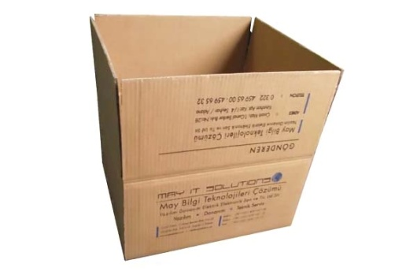
cardboard and package

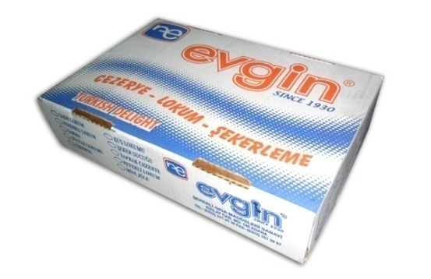

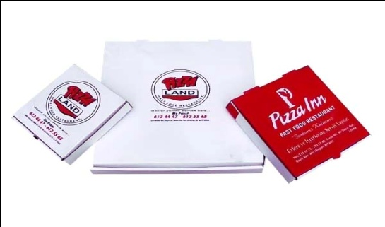

End consumer of your products:
- Cardboard & Packaging Materials Importers,
- Restaurant chains,
- Large Scale Manufacturers (Especially food industry)

Main applications of the product:
Packaging every kind of products for
- Food Sector
- Textile Sector
- Cargo & transportation Sector

3. COMMERCIAL PROFILE

Main factor of competitiveness of your company:

Design Price / quality
Quality Brand name / Presentation
Technology Range of product
Other (specify):

4. MARKET INFORMATION

What type of business contacts you are seeking:

Importer/Distributor/Wholesaler
Agent/Sales Representative
Franchising
Joint Venture Partner
License
Other (specify):

Is your company in contact with local companies? Yes No

Do you want to contact some specific companies? Yes No

If yes, specify the name and the address of the companies:

5. ADDITIONAL COMMENTS/INFORMATION ABOUT YOUR BUSINESS:

Our company has the flexibility policy to easily respond to specific customer demands by producing flexo printed on corrugated cardboard boxes, display stands, kraft - liner, test - liner, fluting paper boxes.

Our products are environmentally friendly, harmless to human health and recycled 100%.

Our products have become known in the international market.

