Company Profile

COMPANY NAME: Olcum Orman Urunleri Nak. İns. Mlz. Iletisim, Hiz.OtoYedek
Parça San.ve Tic.Ltd.Şti.
YEAR OF ESTABLISHMENT: 2003

1. ARE YOU INTERESTED IN: EXPORTING IMPORTING BOTH

2. descriBE the activity/PRODUCTS/SERVICES YOU SEEK TO PROMOTE
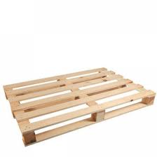
wooden pallet, wooden chest
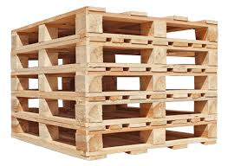

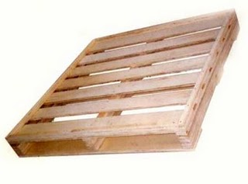

End consumer of your products:
- Pallet importers,
- Large Scaled Manufacturers/Exporters (Especially food industry)
- Freight companies

Main applications of the product:
- Palette for transportation companies
- Wooden chest for food sector to carry fruits and vegetables

3. COMMERCIAL PROFILE

Main factor of competitiveness of your company:

Design Price / quality
Quality Brand name / Presentation
Technology Range of product
Other (specify):

4. MARKET INFORMATION

What type of business contacts you are seeking:

Importer/Distributor/Wholesaler
Agent/Sales Representative
Franchising
Joint Venture Partner
License
Other (specify):

Is your company in contact with local companies? Yes No

Do you want to contact some specific companies? Yes No

If yes, specify the name and the address of the companies:

5. ADDITIONAL COMMENTS/INFORMATION ABOUT YOUR BUSINESS:

