Business to Business Company Profile
Section 1. Company Information
- Name: Yosef Kamal Hassouneh
Company: Alshark Elctrode Company
Website: www:alshark-co.com City: Hebron District: Hebron
About us:
The company was established in 1973 to produce all kinds of welding bars in cooperation with Oerlikon Swiss Co. The company obtained the international standards certificate “ISO9002” in 1990. Within its development plan; the company established a production line for winded wire and soft wire. Another production line for steel nails was established. The company sells its products in the West Bank and exports to Jordan.
- Al-shark has taken the "ISO9002” from its first beginning.
- Al-shark is ready to obtain other international certificates of quality approval in accordance with the customer requests.
- Al-shark always look forward to meet and satisfy the customer requirement everywhere.
- Al-shark has its own laboratories to perform necessary tests for the raw materials and the products "electrodes" to ensure the conformance with the required specifications.

- Industry: we are manufacturing welding Electrodes, stainless steel, mild steel
- Major product(s)/services(s):
welding wire, mild steel, cutting electrodes, cast Iron, Stainless steel, nickel electrodes CO2 welding wire.
- End consumer of your products: Construction companies, contractors
- Main applications of the product: used for construction
- Main factor of competitiveness of your company:
Design Price / quality
quality Brand name / presentation
Technology Range of products
Other (specify): ______________________________________________________________

- What kind of business contact you are seeking:
Importer / Distributor / Wholesaler of construction metal materials and tools, supplies of construction materials.
Agent / Sales Representative
Franchising
Joint venture partner
License
Other (specify): ______________________________________________________________

- Is your company in contact with local companies? Yes No
- Do you want to contact some specific companies? Yes No

- Total Number of employees
Full time: 28 Part time:
- Does your company currently EXPORT?
Yes (go to question 10) No (go to question 21)
Section 2. Currently exporting
- How many years has your company exported? 40 years
- What percentage of your company's total sales is derived from exporting?
Less than 10% 40 - 54%
10 – 24% 55 - 69%
15 - 39% 70% or more
- Do exports account for more, less or the same percentage of your sales as two years ago?
More Less Same
- Do you expect your sales from exporting to increase, decrease, or stay the same over the next two years?
Increase Decrease Stay the same
- Please check all international activities in which your company is currently engaged:
Export of goods and/or services
Import of goods and/or services
Licensing agreements
Distribution agreements
Subsidiaries or own sales forces in other countries
Company is owned by overseas corporation (51%+)
Joint ventures
Research and development alliances
Other strategic alliances
If "other strategic alliances" has been checked. please briefly describe the nature of these alliances: participation in international fair

- Please list the top three countries with which your company's current international activities occur and the percentage or your international sales for each country.
Country Percentage of international sales
we export to Jordan 40% , we Export to Israel 2%

- Please check all international activities in which your company plans to be engaged over the next two years.
(Include expansion of existing and possible new activities.)
Export of goods and/or services
Import of goods and/or services
Licensing agreements
Distribution agreements
Subsidiaries or own sales forces in other countries
Company is owned by overseas corporations (51%+)
Joint ventures
Research and development alliances
Other strategic alliances
If “other strategic alliances" has been checked, please briefly describe the nature of these alliance ____________________________________________________________________________________________________________________________________________________________

- Does your company have a strategic plan for increasing the international business dimension of your activities?
Yes No
- Please list any new countries that you believe will be exporting to over the next two years.
EYGEPT
- Please list the top three organizations that have assisted your company in its international activities.
- What are the main areas in which your company needs assistance with its international activities?
------
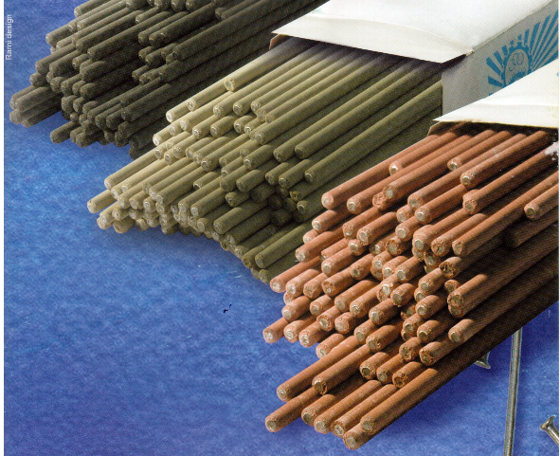
More pictures available in the website
